**For the system supporting mrsas drivers we can load as below:**

**For eg**: **R730 dell having Perc h830, this mode of installation succeeds.**

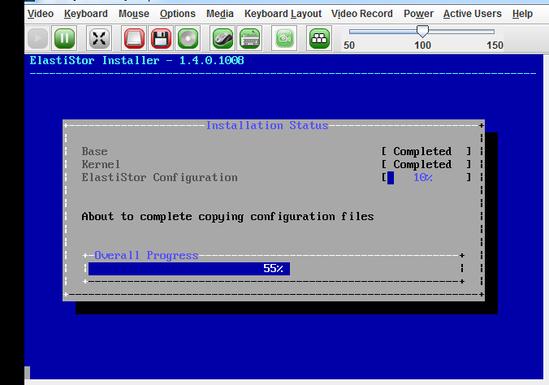

**These are the following steps:**

1>You need to restart the installation.

2>Press esc key at welcome to Elastistor screen.

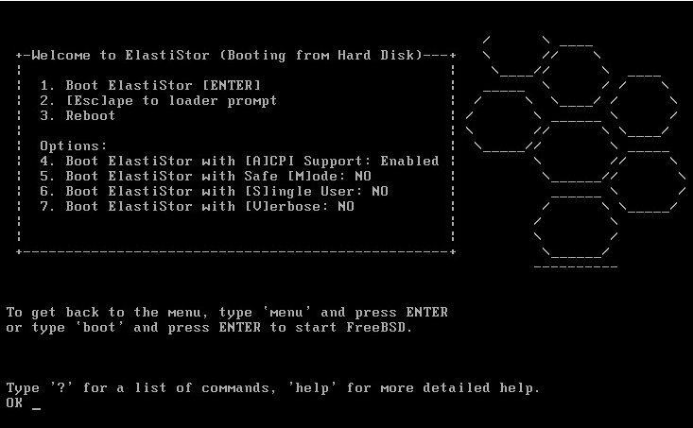

3>Type the following command in ok prompt:

**Set hw.mfi.mrsas_enable=”1”**

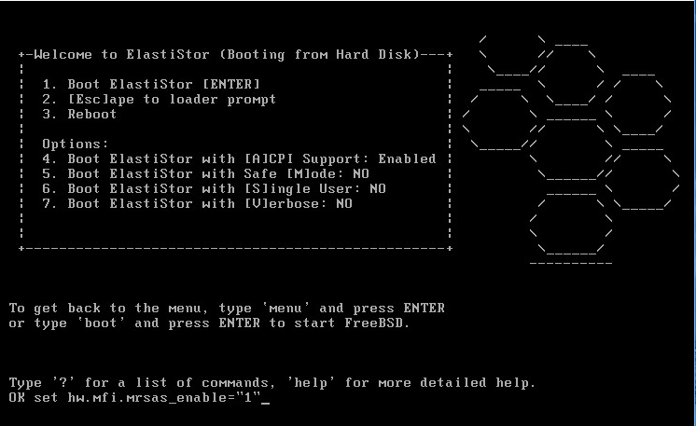

**4>**You can check it by typing show command in OK prompt and

then you can see **hw.mfi.mrsas_enable=1**



5>Type boot command in Ok prompt. It will start the installation.



6> After installation is completed. The system will reboot.

7>Again while rebooting you need to follow step 2 to 5.

8>Now when server comes up you need to login and go to device.hints file.

**Vi /boot/device.hints**



9> you need to add this statement in devices.hints file at the end and then save the file.

**hw.mfi.mrsas_enable="1"**

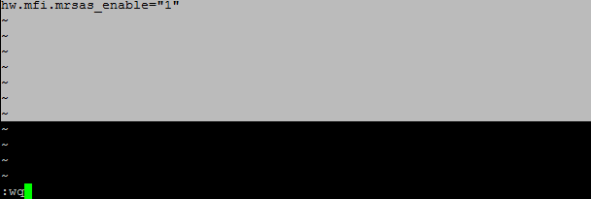

10> Then reboot the server. This time it should come up without stucking at booting screen.